**Participant ID _________**

**INSTRUCTIONS**

**WELCOME**

This is an experiment in the economics of strategic decision making. The instructions for the experiment are simple. If you follow them closely and make appropriate decisions, you can earn an appreciable amount of money. It is very important that you remain silent and do not look at other people’s work. If you have any questions, or need assistance of any kind, please raise your hand and an experimenter will come to you. If you talk, laugh, exclaim out loud, etc., you will be asked to leave and you will not be paid. We expect and appreciate your cooperation.

At the end of the experiment you will be paid privately and in cash. In order to keep your decisions private, *please do not reveal your choices to any other participant.* You may cease participation at any point; if you do, you will receive the $7 participation fee but will not receive any additional compensation.

**THE EXPERIMENT**

The experiment will proceed in **five** parts. Each part contains decision problems that require you to make a series of economic choices which determine your total earnings. The currency used in Parts 1 and 2 of the experiment is U.S. Dollars. The currency used in Parts 3-5 of the experiment is Francs. These Francs will be converted to U.S. Dollars at a rate of **15** Francs to **1** dollar.

**INSTRUCTIONS FOR PARTS 1 - 2**

In PARTS 1 and 2 of the experiment, you will be asked to make a series of choices in decision problems. How much you receive will depend partly on **chance** and partly on the **choices** you make.

In each PART, you will see a table with 20 lines. You will state whether you prefer Option A or Option B in each line. You should think of each line as a separate decision you need to make. However, in each PART only **one line** will be the ‘line that counts’ and will be paid out. In particular, at the end of the experiment, the computer will randomly choose a line by throwing a 20-sided die. The number on the die indicates which **line** in that part will be paid out. For instance, if the number on the first roll of the die is 17, you will be paid for your choice in line 17 in PART 1. If the number on the second roll of the die is 8, you will be paid for your choice in line 8 in PART 2.

Because each line is equally likely to be selected, and because you do not know which line will be selected when you make your choices, you should pay close attention to the choices you make in each line.

**Both PARTS have very different row payouts and probabilities. So you should think of each part as separate.**

**PART 1**

For each line in the table, please state whether you prefer option A or option B. Notice that there are a total of **20 lines** in the table – you should think of each line as a separate decision you need to make.

Your earnings for the selected line depend on which option you chose: If you chose option B in that line, you will receive an amount of money specified by option B – between **$0.25** and **$5** – depending on the line. If you chose option A in that line, you will receive either **$5** or **$0**. To determine your earnings in the case you chose option A the computer will draw a random number. To visualize how this is done, picture the computer randomly drawing a ball from a bag containing twenty balls. There are **ten pink** and **ten green** balls in the bag. This means that there is a 50% chance that the drawn ball is pink and a 50% chance that it is green. If the drawn ball is pink, you will receive $5 which corresponds to the payoffs in the column labelled pink. If the drawn ball is green, you will receive $0, which corresponds to the payoffs in the column labelled green.

For instance, suppose the chosen line is 6 (see below). If you chose Option B, then you get $1.50 for sure. If you chose Option A, then there is a 50% chance you get $5 and 50% chance you get $0.

While you have all the information in the table, you should input all your 20 decisions into the computer. The actual drawing of the ball and the throw of the 20-sided die by the monitor computer for this part of the experiment will be done at the end of the experiment. Use the following tables for your reference:

|  |  |  |  |  |
| --- | --- | --- | --- | --- |
| **Decision**  **Number** | **OPTION A** | | **OPTION B** | **Choose**  **A or B** |
| **PINK** | **GREEN** |
| 1 | **$5.00** with 50% chance | **$0.00** with 50% chance 1,2,3,4,5,6,7,8,9,10,11,12,13,14,15,16,17,18,19,20 | **$0.25** for sure |  |
| 2 | **$5.00** with 50% chance | **$0.00** with 50% chance 1,2,3,4,5,6,7,8,9,10,11,12,13,14,15,16,17,18,19,20 | **$0.50** for sure |  |
| 3 | **$5.00** with 50% chance | **$0.00** with 50% chance 1,2,3,4,5,6,7,8,9,10,11,12,13,14,15,16,17,18,19,20 | **$0.75** for sure |  |
| 4 | **$5.00** with 50% chance | **$0.00** with 50% chance 1,2,3,4,5,6,7,8,9,10,11,12,13,14,15,16,17,18,19,20 | **$1.00** for sure |  |
| 5 | **$5.00** with 50% chance **$10.00** with 50% chance | **$0.00** with 50% chance 1,2,3,4,5,6,7,8,9,10,11,12,13,14,15,16,17,18,19,20 | **$1.25** for sure |  |
| 6 | **$5.00** with 50% chance **$10.00** with 50% chance | **$0.00** with 50% chance 1,2,3,4,5,6,7,8,9,10,11,12,13,14,15,16,17,18,19,20 | **$1.50** for sure |  |
| 7 | **$5.00** with 50% chance **$10.00** with 50% chance | **$0.00** with 50% chance 1,2,3,4,5,6,7,8,9,10,11,12,13,14,15,16,17,18,19,20 | **$1.75** for sure |  |
| 8 | **$5.00** with 50% chance **$10.00** with 50% chance | **$0.00** with 50% chance 1,2,3,4,5,6,7,8,9,10,11,12,13,14,15,16,17,18,19,20 | **$2.00** for sure |  |
| 9 | **$5.00** with 50% chance **$10.00** with 50% chance | **$0.00** with 50% chance 1,2,3,4,5,6,7,8,9,10,11,12,13,14,15,16,17,18,19,20 | **$2.25** for sure |  |
| 10 | **$5.00** with 50% chance **$10.00** with 50% chance | **$0.00** with 50% chance 1,2,3,4,5,6,7,8,9,10,11,12,13,14,15,16,17,18,19,20 | **$2.50** for sure |  |
| 11 | **$5.00** with 50% chance **$10.00** with 50% chance | **$0.00** with 50% chance 1,2,3,4,5,6,7,8,9,10,11,12,13,14,15,16,17,18,19,20 | **$2.75** for sure |  |
| 12 | **$5.00** with 50% chance **$10.00** with 50% chance | **$0.00** with 50% chance 1,2,3,4,5,6,7,8,9,10,11,12,13,14,15,16,17,18,19,20 | **$3.00** for sure |  |
| 13 | **$5.00** with 50% chance **$10.00** with 50% chance | **$0.00** with 50% chance 1,2,3,4,5,6,7,8,9,10,11,12,13,14,15,16,17,18,19,20 | **$3.25** for sure |  |
| 14 | **$5.00** with 50% chance **$10.00** with 50% chance | **$0.00** with 50% chance 1,2,3,4,5,6,7,8,9,10,11,12,13,14,15,16,17,18,19,20 | **$3.50** for sure |  |
| 15 | **$5.00** with 50% chance **10.00** with 50% chance | **$0.00** with 50% chance 1,2,3,4,5,6,7,8,9,10,11,12,13,14,15,16,17,18,19,20 | **$3.75** for sure |  |
| 16 | **$5.00** with 50% chance **v$10.00** with 50% chance | **$0.00** with 50% chance 1,2,3,4,5,6,7,8,9,10,11,12,13,14,15,16,17,18,19,20 | **$4.00** for sure |  |
| 17 | **$5.00** with 50% chance **$10.00** with 50% chance | **$0.00** with 50% chance 1,2,3,4,5,6,7,8,9,10,11,12,13,14,15,16,17,18,19,20 | **$4.25** for sure |  |
| 18 | **$5.00** with 50% chance **$10.00** with 50% chance | **$0.00** with 50% chance 1,2,3,4,5,6,7,8,9,10,11,12,13,14,15,16,17,18,19,20 | **$4.50** for sure |  |
| 19 | **$5.00** with 50% chance **$10.00** with 50% chance | **$0.00** with 50% chance 1,2,3,4,5,6,7,8,9,10,11,12,13,14,15,16,17,18,19,20 | **$4.75** for sure |  |
| 20 | **$5.00** with 50% chance **$10.00** with 50% chance | **$0.00** with 50% chance 1,2,3,4,5,6,7,8,9,10,11,12,13,14,15,16,17,18,19,20 | **$5.00** for sure |  |

**PART 2**

For each line in the table, please state whether you prefer option A or option B. Notice that there are a total of **20 lines** in the table – you should think of each line as a separate decision you need to make.

Your earnings for the selected line depend on which option you chose: If you chose option B in that line, you will receive **$0**. If you chose option A in that line, you can receive either a loss between -**$0.50** and **-$10,** depending on the line, or a gain of **$5**. To determine your earnings in the case you chose option A the computer will randomly draw a ball from a bag containing twenty balls. To visualize how this is done, picture the computer randomly drawing a ball from a bag containing twenty balls. There are **ten pink** and **ten green** balls in the bag. This means that there is a 50% chance that the drawn ball is pink and a 50% chance that it is green. If the drawn ball is pink, you will receive -$x (the exact amount depends on the line chosen in the column labelled pink). If the drawn ball is green, you will receive $5, which corresponds to the payoffs in the column labelled green.

For instance, suppose the chosen line is 6 (see below). If you chose Option B, then you get $0 for sure. If you chose Option A, then there is a 50% chance you lose $3 and 50% chance you get $5.

While you have all the information in the table, you should input all your 20 decisions into the computer. The actual drawing of the ball and the throw of the 20-sided die by the monitor computer for this part of the experiment will be done at the end of the experiment. Use the following tables for reference:

|  |  |  |  |  |  |
| --- | --- | --- | --- | --- | --- |
| **Decision**  **Number** | **OPTION A** | | | **Option B** | **Choose**  **A or B** |
| **PINK** | **GREEN** | |
| 1 | **-$0.50** with 50% chance | | **$5.00** with 50% chance | **$0.00** for sure |  |
| 2 | **-$1.00** with 50% chance | | **$5.00** with 50% chance | **$0.00** for sure |  |
| 3 | **-$1.50** with 50% chance | | **$5.00** with 50% chance | **$0.00** for sure |  |
| 4 | **-$2.00** with 50% chance | | **$5.00** with 50% chance | **$0.00** for sure |  |
| 5 | **-$2.50** with 50% chance | | **$5.00** with 50% chance **$10.00** with 50% chance | **$0.00** for sure |  |
| 6 | **-$3.00** with 50% chance | | **$5.00** with 50% chance **$10.00** with 50% chance | **$0.00** for sure |  |
| 7 | **-$3.50** with 50% chance | | **$5.00** with 50% chance **$10.00** with 50% chance | **$0.00** for sure |  |
| 8 | **-$4.00** with 50% chance | | **$5.00** with 50% chance **$10.00** with 50% chance | **$0.00** for sure |  |
| 9 | **-$4.50** with 50% chance | | **$5.00** with 50% chance **$10.00** with 50% chance | **$0.00** for sure |  |
| 10 | **-$5.00** with 50% chance | | **$5.00** with 50% chance **$10.00** with 50% chance | **$0.00** for sure |  |
| 11 | **-$5.50** with 50% chance | | **$5.00** with 50% chance **$10.00** with 50% chance | **$0.00** for sure |  |
| 12 | **-$6.00** with 50% chance | | **$5.00** with 50% chance **$10.00** with 50% chance | **$0.00** for sure |  |
| 13 | **-$6.50** with 50% chance | | **$5.00** with 50% chance **$10.00** with 50% chance | **$0.00** for sure |  |
| 14 | **-$7.00** with 50% chance | | **$5.00** with 50% chance **$10.00** with 50% chance | **$0.00** for sure |  |
| 15 | **-$7.50** with 50% chance | | **$5.00** with 50% chance **10.00** with 50% chance | **$0.00** for sure |  |
| 16 | **-$8.00** with 50% chance | | **$5.00** with 50% chance **v$10.00** with 50% chance | **$0.00** for sure |  |
| 17 | **-$8.50** with 50% chance | | **$5.00** with 50% chance **$10.00** with 50% chance | **$0.00** for sure |  |
| 18 | **-$9.00** with 50% chance | | **$5.00** with 50% chance **$10.00** with 50% chance | **$0.00** for sure |  |
| 19 | **-$9.50** with 50% chance | | **$5.00** with 50% chance **$10.00** with 50% chance | **$0.00** for sure |  |
| 20 | **-$10.00** with 50% chance | | **$5.00** with 50% chance **$10.00** with 50% chance | **$0.00** for sure |  |

**INSTRUCTIONS FOR PART 3**

**YOUR DECISION**

This part of the experiment consists of **20** decision-making periods. How much you receive will depend partly on the choicesyou make and partly on the choices made by the other participants in the room.

The 16 participants in today’s experiment will be randomly re-matched every period into **8 groups with 2 participants in each group.** Therefore, the specific person who is the other participant in your group will change randomly after each period. The group assignment is anonymous, so you will not be told which of the participants in this room are assigned to your group.

Each period you and the other participant in your group will simultaneously make investment decisions. You will be given an initial endowment of **100** francs that you may use to make an investment. Your investment in each period cannot **exceed 100 francs** (any number, including 2 decimal points). The more you invest, the more likely you are to win a particular period. This will be explained in more detail later. The participant who wins receives **the reward of 100 francs**.

Your total earnings depend on whether or not you receive the reward and on how many francs you spent on investment. An example of your decision screen is shown below in Figure 1:

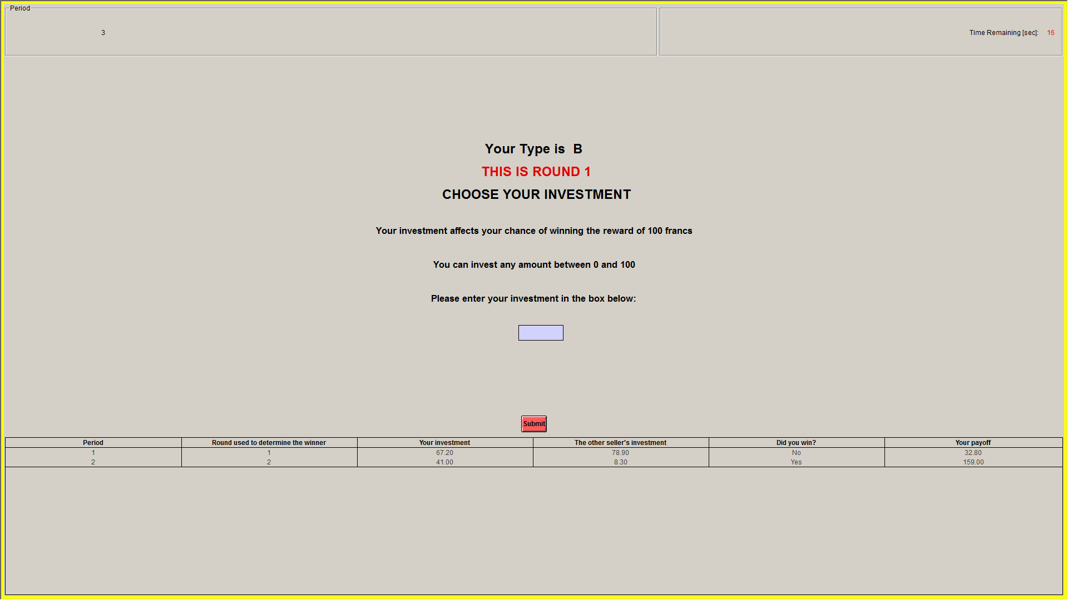

**Figure 1 – Decision Screen in Round 1**

**THE TWO ROUNDS**

In every period, there will be two rounds of decision-making. Regardless of your type, you and the other participant must submit an investment decision in Round 1. If **your type is B**, this choice is irreversible and thus cannot be changed. After submitting your Round 1 investment,

* **if your type is A**, you will learn the other participant’s Round 1 investment and you will be asked whether you wish to change your investment. We refer to this as Type A’s Round 2 investment. You are not required to change your investment in which case your Round 2 investment is equal to your Round 1 investment.
* **if your type is B** you will be asked to submit a guess regarding the other participant’s decision to change his or her investment in Round 2. Please submit your best guess. Note that your guess has absolutely no impact on how the payoffs are determined.

To determine the payoffs, the computer will first select which investments are used to determine the winner. If your Type is B, your Round 1 investment will be used for sure. If your Type is A, then there is a **25% chance** that your Round 1 investment will be used and a **75% chance** that your Round 2 investment will be used. In other words, with a 25% chance, the computer determines the winner using Type A’s Round 1 investment and Type B’s Round 1 investment; and with a 75% chance, the computer determines the winner using Type A’s Round 2 investment and Type B’s Round 1 investment.

Note that your player type – Type A or Type B – is randomly determined every period. Your type in a particular period is not determined by your investment decisions in previous periods or by your type in previous periods. That is, in each period, you are equally likely to be the Type A or the Type B participant in your group.

An example of the decision screen for Type A in Round 2 is shown in Figure 2. Figure 3 shows the corresponding decision screen for Type B in Round 2.

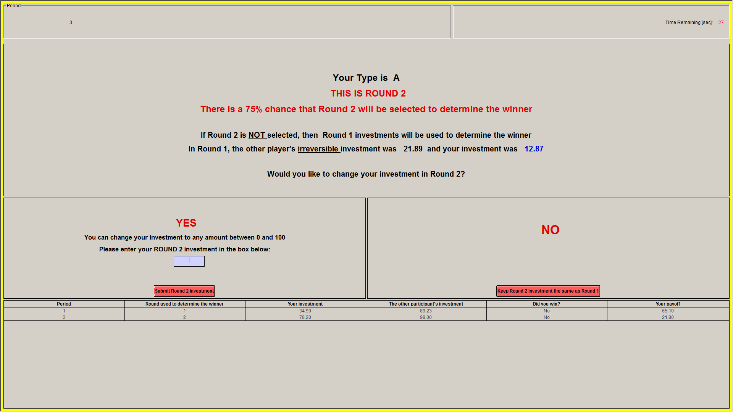

**Figure 2 – Decision Screen for Type A in Round 2**

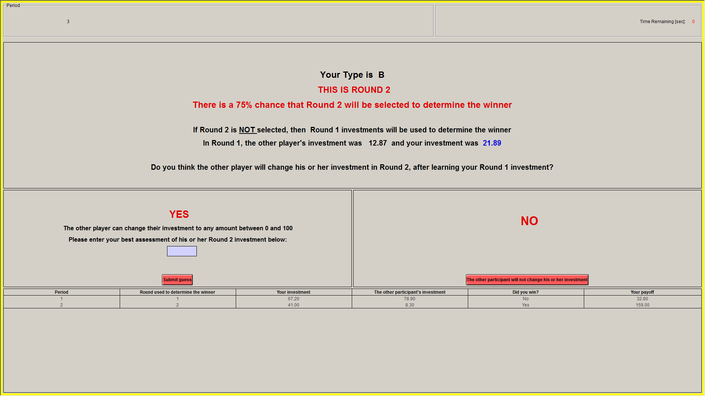

**Figure 3 – Decision Screen for Type B in Round 2**

**DETERMINING THE WINNER**

If your investment is higher than the other participant’s then you win the reward. So, if you invest X francs while the other participant invests Y francs, where X > Y then the computer will choose you as the winner for the period. For instance, if your investment is 20 francs and the other participant’s investment is 10 francs, then you win. If instead X = Y, then the computer will randomly determine the winner so that in this case, both you and the other participant are equally likely to win.

**YOUR PAYOFF**

In every period, your payoff for the period depends on how many Francs you invest and whether or not you win in that period.

$$Your Payoff if you win= 100+100 – your investment$$

$$Your payoff if you lose= 100+0 – your investment$$

**END OF THE PERIOD**

After both participants make their decisions in Round 1 and Round 2, the computer will make a random draw to select which investments are used to determine the winner. You will then observe the outcome of the period – your investment, the other participant’s investment, the round used to determine the winner, whether or not you won as well as your payoff for this period, as shown in Figure 4.

**Importantly, note that you will be randomly re-matched with a different participant at the start of the next period.**

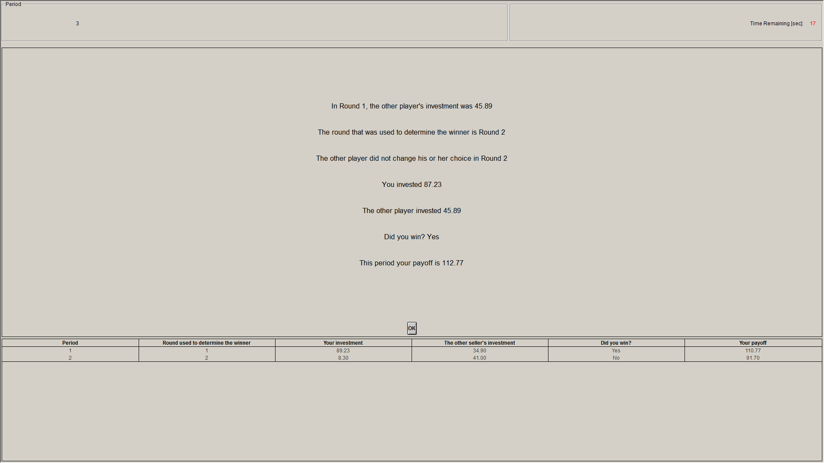

**Figure 4 – Outcome Screen**

At the end of the experiment the computer will roll a 20 sided die to randomly select 1 out of 20 periods from Part 3 for actual payment. Your earnings will be converted to a U.S. dollar payment, as shown on the last page of your personal record sheet.

**Are there any questions?**

**INSTRUCTIONS FOR PART 4**

This part of the experiment also consists of **20** decision-making periods where you will be randomly re-matched with another participant in every period. Your player type – Type A or Type B – will also be randomly determined at the beginning of each period, as in Part 3. All other rules for Part 4 are the same as the rules for Part 3.

The only difference in this part of the experiment is that the probability that the computer chooses Round 1 investments to determine the winner is now **75%**. To summarize, with a 75% chance, the computer determines the winner using Type A’s Round 1 investment and Type B’s Round 1 investment; and with a 25% chance, the computer determines the winner using Type A’s Round 2 investment and Type B’s Round 1 investment.

At the end of the experiment, the computer will roll a 20 sided die to randomly select 1 out of 20 periods from Part 4 for actual payment. Your earnings will be converted to a U.S. dollar payment, as shown on the last page of your personal record sheet.

**INSTRUCTIONS FOR PART 5**

The last part of the experiment consists of only 1 decision-making period. The rules for PART 5 are the same as the rules for PARTS 3 and 4. At the beginning of the period, you will be randomly matched with another participant. You will be given an initial endowment of 100 Francs. You will use this endowment to make an investment in order to be **a winner**. For each Franc you investment you will receive one lottery ticket. At the end of the single period the computer draws randomly one ticket among all the tickets purchased by you and the other participant in your group. The owner of the drawn ticket becomes a winner. Thus, your chance of becoming a winner is given by the number of Francs you invest divided by the total number of Francs in your group investment.

The only difference is that in PART 5 the winner does not receive the reward. Therefore, the reward is worth 0 Francs to you and the other participant in your group. After all participants have made their decisions, your earnings in Francs are calculated:

$$Your Payoff if you win= 100+0 – your investment$$

$$Your payoff if you lose= 100+0 – your investment$$

After all participants have made their decisions, your payoff will be displayed on the outcome screen. Your earnings will be converted to a U.S. dollar payment, as shown on the last page of your personal earnings sheet.

**END OF THE EXPERIMENT**

After Part 5 has ended, we will ask you to answer a short questionnaire. The computer will make the draws for each part when everyone has finished their questionnaire. The last screen will contain your earnings from each part of the experiment. Please write these in the earnings sheet, and the experimenter will come to your station to pay you in cash privately. You urge you to exit quietly and not discuss the experiment with others.

­**Earnings Sheet Participant ID _________**

|  |  |  |  |
| --- | --- | --- | --- |
|  |  | **Result** | **Your Earnings** |
|  | | | |
| 1. PARTS 1 - 2 | PART 1 earnings in US $ | | $ |
| PART 2 earnings in US $ | | $ |
|  | | | |
| 1. PART 3 -5 | PART 3 earnings in Francs Period chosen |  |  |
| PART 4 earnings in Francs Period chosen |  |  |
| PART 5 earning in Francs | |  |
| Total earnings in Francs | |  |
| Total earnings in US $ (divide the above total by 15) | | $ |
|  | |  |
|  | | | |
| TOTAL: (A) + (B) + $7 Participation Fee | | | $ |